**Swell Coffee Website**

Hi Guys, the website is finished and just needs a few extra bits doing.

**Hostinger Account**

First up make a Hostinger account and send me the long-in details.

**Website Address/Domain**

First is to get a domain name: This is the website address and name.

I’ve had a look and swellcoffee.co.uk and .com is already taken but **swell-coffee.co.uk** is free. Choose a name that suits you. You can buy a domain from a range of places and it’s a yearly fee, then you’re paying to keep it as long as like – between £3-£8 a year.

Place to buy a domain:

<https://www.hostinger.co.uk/domains?utm_campaign=Generic-Domains|NT:Se|LO:UK&utm_medium=ppc&gad_source=1&gclid=Cj0KCQiAouG5BhDBARIsAOc08RT2yojHT8Mgp9ClNcFH7p6ocLT5CSEwZfuLeXigyjMktERv0aHcelIaAqHfEALw_wcB>

**Web Hosting Plan**

Next is to buy the web hosting plan. We only need the most basic one here because the website is very simple and doesn’t need any extras. After the first month it’ll be about £3/m.

I’ll be able to set everything else up for you.

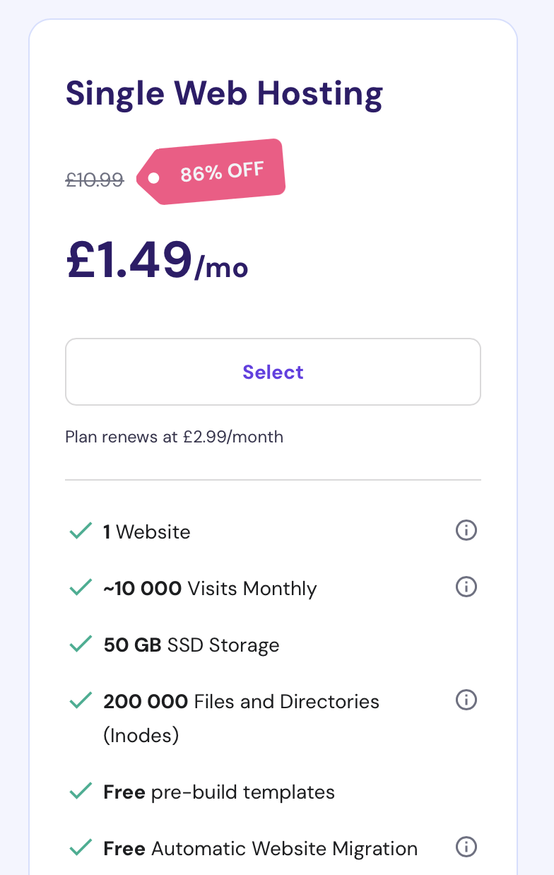

**Website content**

I’ve taken the liberty of adding some stuff as placeholder text (chatGPT and whatnot). Let me know if there’s anything you’d like to change.

**Look/Fonts**

Take a look at the colours of the fonts and let me know if you want any font-style changing

<https://www.realtimecolors.com/?colors=43267e-ADD2D5-79adb2-f2dcff-ffeca0&fonts=Inter-Inter>

**Under the main logo:**

* Coffee cart for hire

**Three informational sections in between pictures - keep these bits short if you can:**

* Hire us for all events!
* Sweet moments, freshly made.
* Taste the art of handmade goodness.

**Contact us**

* Northern Ireland
* 07720695526
* Send me your business email as I don’t have it
* Send me facebook link if you have it or I’ll remove the facebook stuff

Here’s the FAQ. Let me know what you want to change, and if you want the colour changed as well. The FAQ was a chatGPT job so have a read through.

**Frequently Asked Questions**

**1. What types of events do you cater to?**  
We’re available for all kinds of events—corporate functions, weddings, private parties, markets, festivals, and more! Wherever you need fresh coffee and tasty baked goods, we can bring our cart.

**2. What kind of coffee do you serve?**  
We serve a variety of coffee drinks, including espresso, lattes, cappuccinos, americanos, and more. Our beans are locally sourced, and we brew each cup fresh to order.

**3. Do you offer any non-coffee beverages?**  
Yes! We can serve hot chocolate, chai lattes, and teas. We’re happy to adjust our menu based on your needs, so just let us know if there’s something specific you’re looking for.

**4. Can you accommodate dietary restrictions?**  
Absolutely! Our baked goods can include options for vegan, gluten-free, and dairy-free diets. Please let us know in advance so we can prepare a selection that meets your guests’ needs.

**5. How much space do you need to set up?**  
Our setup is compact and adaptable, so we can fit in most event spaces, indoors or outdoors. We’ll need an area of about 3x3 meters and access to a power source if possible (though we can also bring a generator if needed).

**6. What’s included in the hire package?**  
Our standard package includes our coffee cart, a skilled barista, coffee beans, milk (including dairy-free options), syrups, and a selection of baked goods. We’ll work with you to create a customized menu if desired.

**7. How far in advance do we need to book?**  
We recommend booking as early as possible to secure your date, especially for weekends and busy seasons. However, if you have a last-minute need, feel free to reach out—we’ll do our best to accommodate!

**8. Do you travel to different locations?**  
Yes, we’re mobile and ready to travel to your event location. Just let us know where you’re hosting your event, and we’ll handle the logistics.

**9. How do we book, and what are the payment terms?**  
Simply contact us via our website or phone to discuss your event details and reserve your date. We typically ask for a deposit to confirm the booking, with the balance due on or before the event day.

**10. Can we customize the menu or branding on the cart?**  
Definitely! We can create a tailored menu and even display your event or company branding on the cart. Just let us know what you have in mind, and we’ll work with you to make it happen.

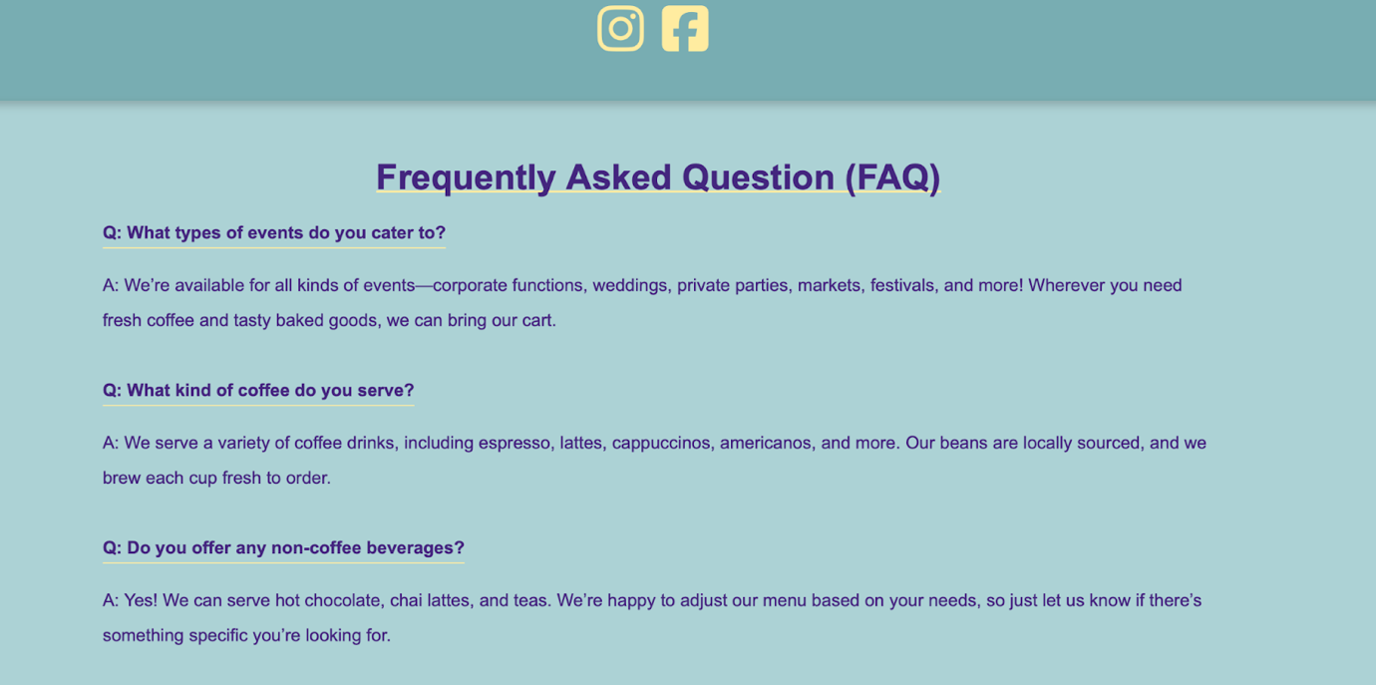

Footer

Desktop

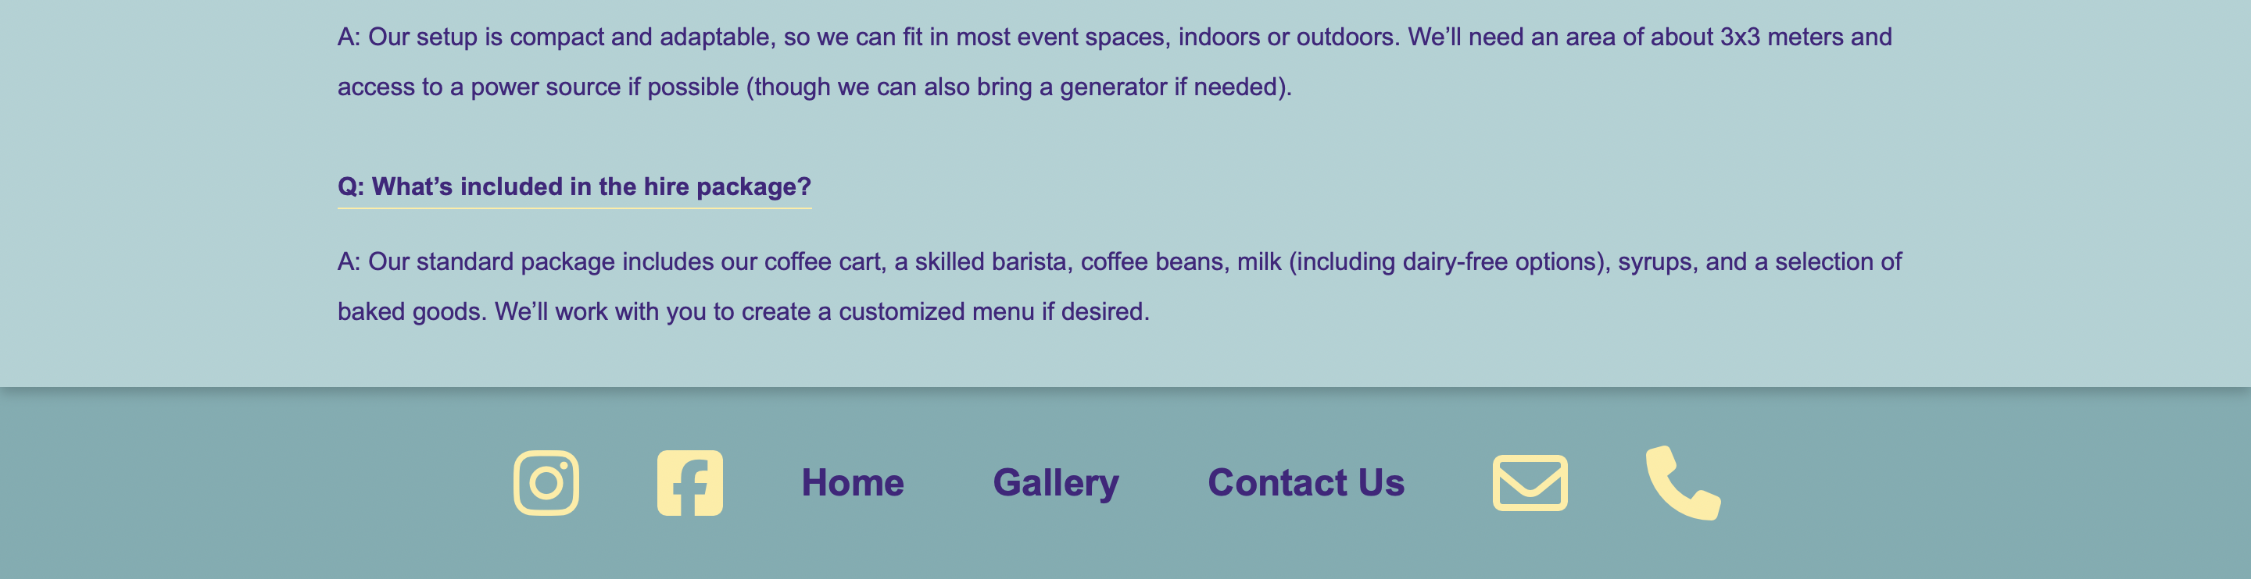

Mobile

